**CREATE NODE-RED SERVICE**

**PROJECT NAME:** SMART SOLUTIONS FOR RAILWAYS

**ID:** PNT2022TMID25665

**Step 1:**

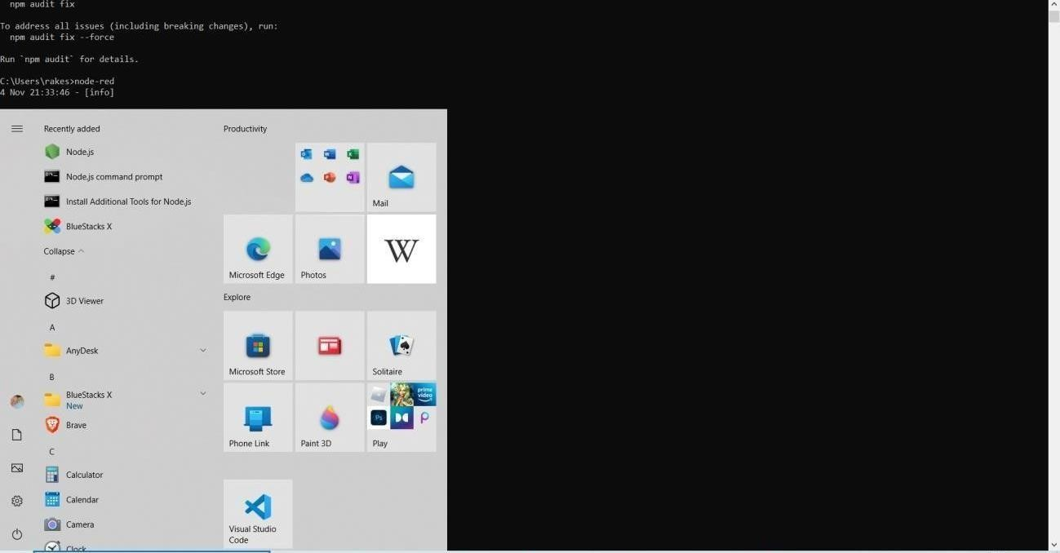

**Step 2:**

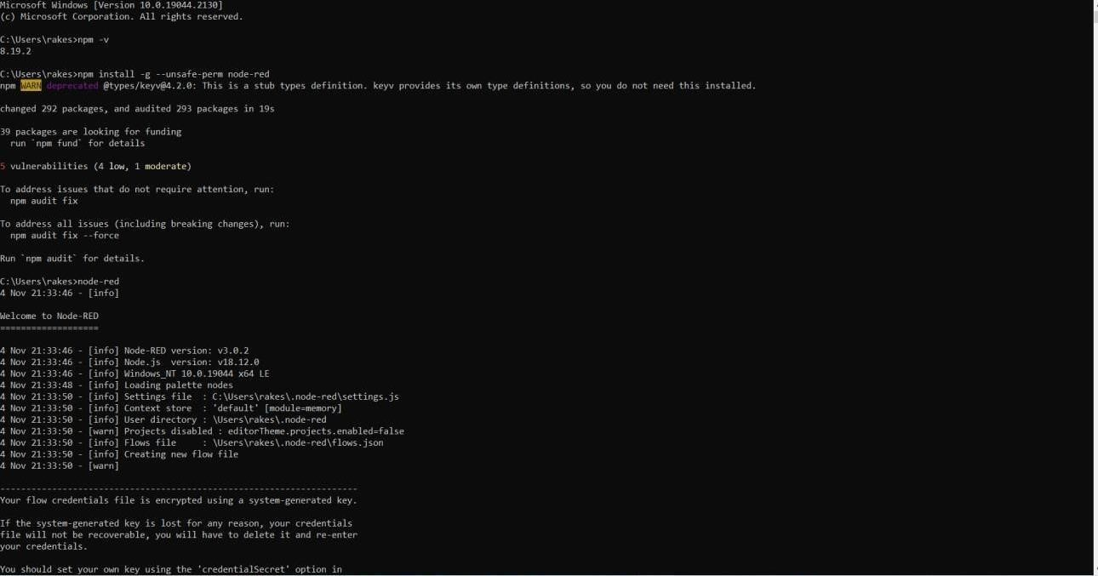

***Step 3:***

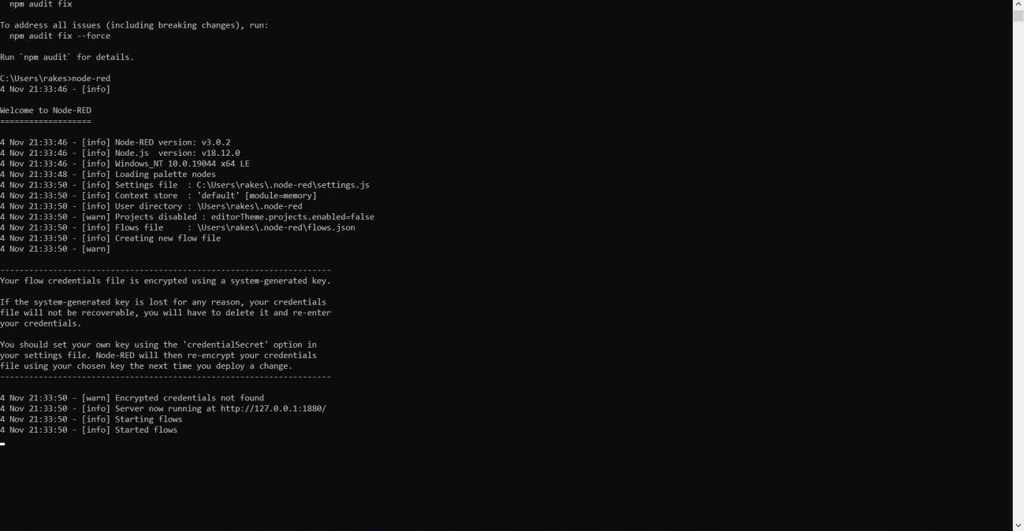

**Step 4:**

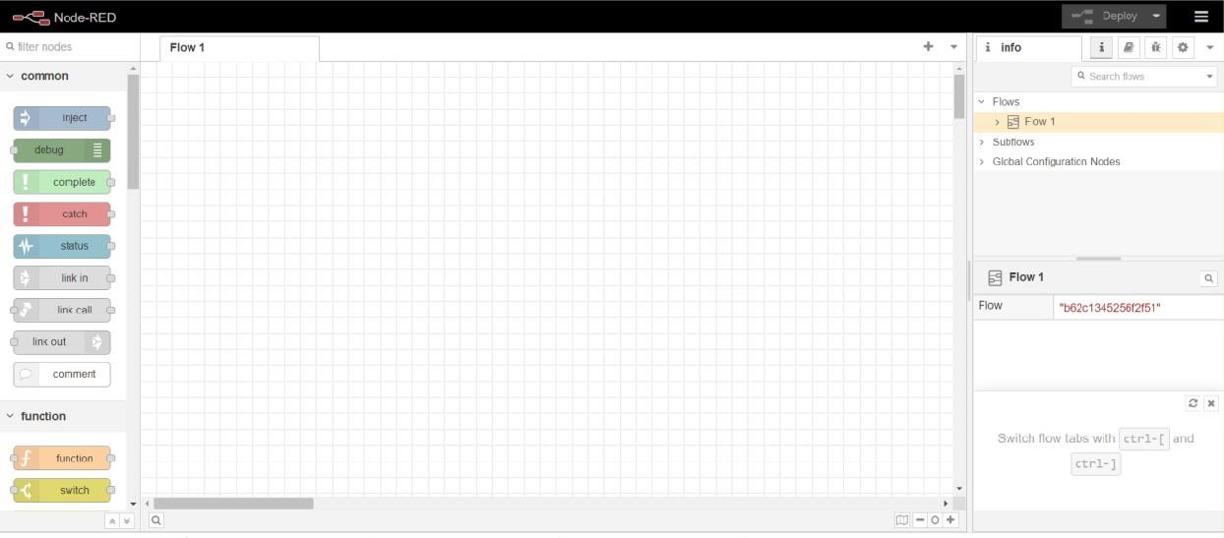

STEP 5:

